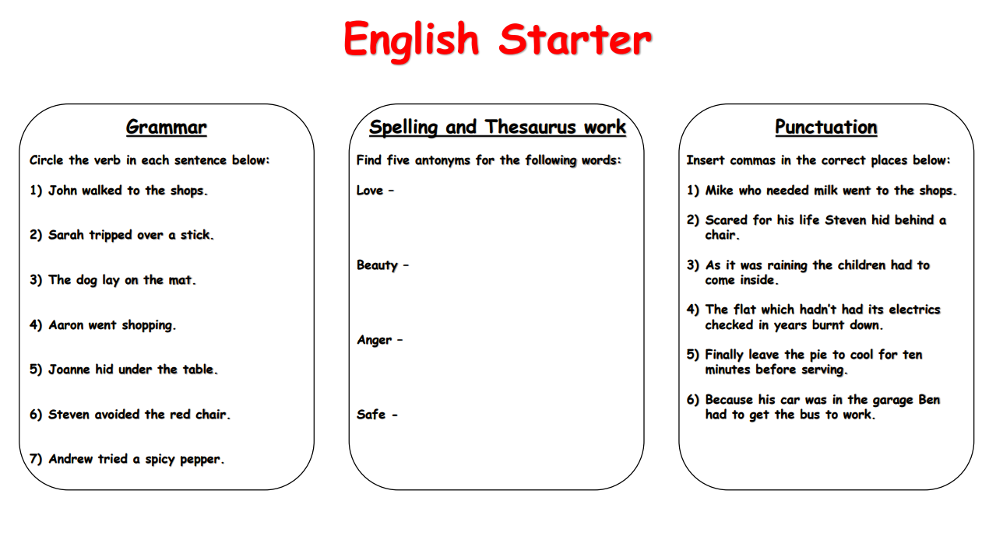
Can you complete these 3 activities?
Remember, antonym means opposite!

