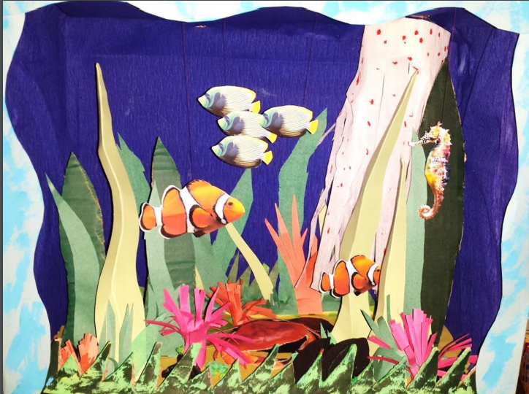
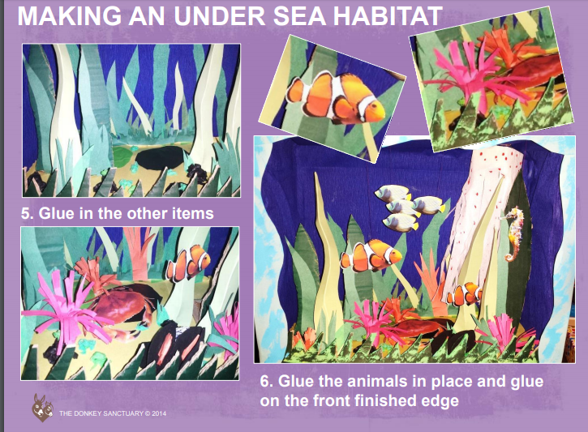
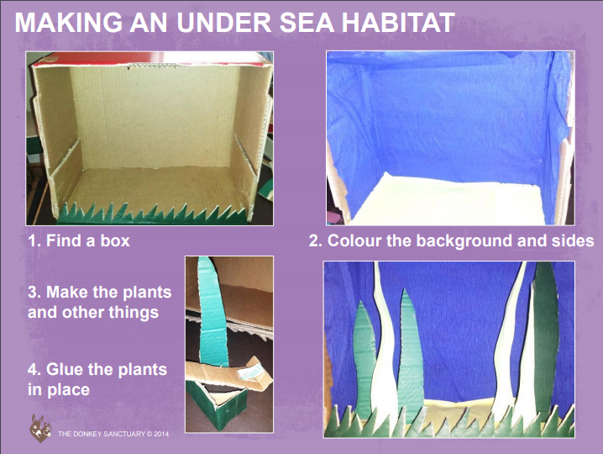

Task: Choose one habitat from the pictures below. Take a shoe box, plan and make your chosen habitat in a box. Be creative. Think what other animals, plants, and trees you will find in your habitats.
