English Write a setting description 15 May
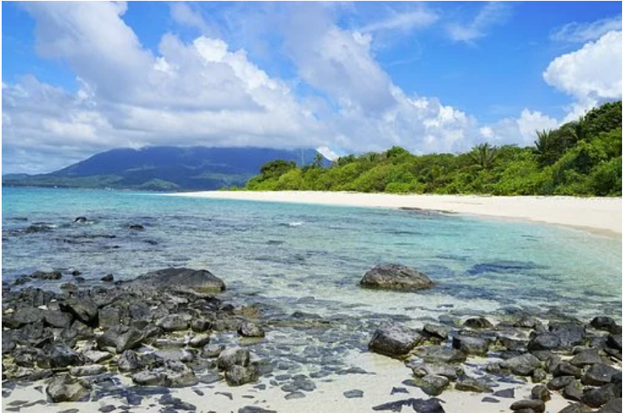
On a bright, sunny day there is one place lots of people want to be, a lovely beach, this is a description about a beach.
Soft white sand covered the ground, smooth on your feet and could make a lovely sandcastle. Many people go here for a nice time to relax and have fun. The turquoise sea calmly went up and down the beach. Large green ferns spread unevenly across the plains. The mountains standing tall and strong in the distance. The air is calm and soothing with a hint of sea salt in the air. Rocks scattered across the seabed, some flat and smooth others small and jagged. The sea calls to you as it glistens in the bright yellow sun, its rays filled the beach with light and made it beautiful to look at as you stand on the hill next to it.

