**Day 1- Conjunctions**

**1. Reading time!**

Read and enjoy the story of *Angry Cat*.

* Who do you feel more sorry for in the story – Cat, or her animal

friends? Why do you feel sorrier for your choice?

**2. Extending sentences**

With a grown-up, carefully read the information on Cat’s Clauses and

Conjunctions and then read each of Cat’s Sentences.

* Highlight the conjunctions in the sentences in one colour and the added clauses in another colour.
* When you have finished, share the Answers with your grown-up and talk about any you didn’t get!

**3. Let’s get ready for writing**

You are going to add conjunctions and clauses of your own to sentences.

* Begin by adding a new clause to each of *Dog’s Sentences*.
* Now add a conjunction *and* a new clause to *Frog’s Sentences*.
* Finish by writing some 2-clause sentences of your own about Angry Cat and her animal friends using conjunctions*.* **For an extra challenge, see if you can place your conjunction at the start of some of your sentences.**

**Now try these Fun-Time Extras**

• On *What Makes Me Angry*, list all the things that can sometimes get you a bit cross.

• Do a drawing of you helping an angry friend calm down. Explain in

sentences what you are doing in the drawing to cheer your friend up.

**Cat’s Clauses and Conjunctions**

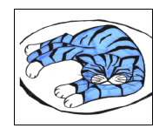

A **sentence is a group of words** that makes sense on its own.

* Cat was angry.
* Squirrel laughed loudly.
* The animals were all a bit scared of Cat.

A sentence has an **active verb (an action or a state of being)** and **a subject (the person or thing doing or being the verb.)**

* Cat was angry.
* Squirrel laughed loudly.
* The animals were all a bit scared of Cat.

We can extend sentences by joining another clause to the original sentence with a conjunction.

* Cat was angry because Dog had eaten her food.

Clauses also have an active verb (had eaten) but they don’t really make complete sense on their own in the way that the original sentence did.

There are **lots of conjunctions** but the ones we are looking at today are:

**because when if**

Conjunctions can go at the start of a sentence. They are doing the same job of linking the original sentence and the new clause but the order is different.

Because Dog had eaten her food, Cat was angry.

**Task 1**: Highlight the conjunctions in the sentences in one colour and the clauses that have been added in another colour.

Remember – the conjunction might be at the start of the sentence!

**because when if**

**Cat’s Sentences**

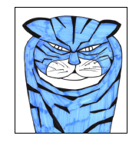

1. Cat did not like getting wet because it made her cold.
2. Crow flapped her wings when Cat purred.
3. Frog jumped out of the pond when Cat walked past.
4. Squirrel threw nuts at Cat if she sat under the tree.
5. Cat lay down in her bed when she was sleepy.
6. If Rat drank the milk, Cat got very cross.
7. Because it was a hot day, all the animals slept in the shade.
8. Cat and Dog cuddled up because they were friends really.

**Task 2: Complete the following sentences-**

**Dog’s Sentences...**



* Dog was sad because ________________________________________
* Frog dived into the pond when ________________________________
* Squirrel ate a huge stack of nuts if ______________________________
* Because Rat came into the room, ________________________________

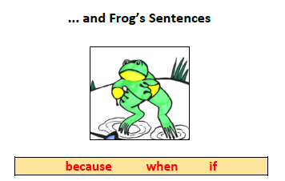

* Crow flew high in the sky _____________________________________
* The animals played in the garden _______________________________
* Dog’s bed was comfy ________________________________________
* _____________ it was a really cold day, __________________________
* ______________ Cat’s bowl was empty, __________________________

Ext: Write your own sentences with conjunctions using because/when/if.

Answers

1. Cat did not like getting wet because it made her cold.
2. Crow flapped her wings when Cat purred.
3. Frog jumped out of the pond when Cat walked past.
4. Squirrel threw nuts at Cat if she sat under the tree.
5. Cat lay down in her bed when she was sleepy.
6. If Rat drank the milk, Cat got very cross.
7. Because it was a hot day, all the animals slept in the shade.
8. Cat and Dog cuddled up because they were friends really.