Ouch! By Kevin Crossley-Holland
Five shepherds fell asleep under a tree. And in their sleep they sighed and stretched and tossed and turned and tied their legs into a knot. When they woke up, they didn't know which leg belonged to who.
“I'm hungry,” said one shepherd.
“And I'm thirsty,” said another.
All five of them were thirsty and hungry, but they were unable to stand up.
“What's wrong with you, men?” shouted a woman on her way to the well: The sun's up and you're still on your backs.'
“We can't stand up,” said the shepherds.
“We don't know which leg belongs to who.”
“What's it worth?” asked the woman.
“Worth?” said one shepherd. “Worth? I don't know. How about ten gold coins?”
“Fifty,” said the woman. “Fifty coins and I'll show you which leg belongs to who.”
“All right,” said the shepherds.
Then the woman unfastened her sun-and-moon brooch, and stuck the pin into the nearest foot.
“Ouch!” yelled one shepherd.
“That's one of yours,” said the woman. “Pull, man! Pull!”
Then the woman stuck another foot.
“Ouch!”
“That's yours.”
“Ouch!”
“Pull, man! Pull!”
One by one the shepherds stood up on their stiff feet. And each poor man fished in his pocket for ten gold coins.

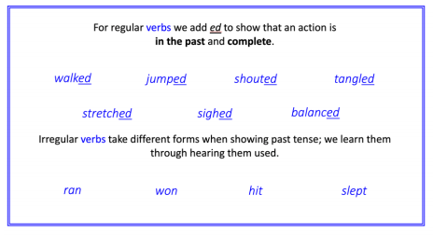
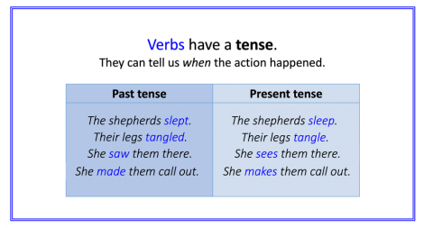
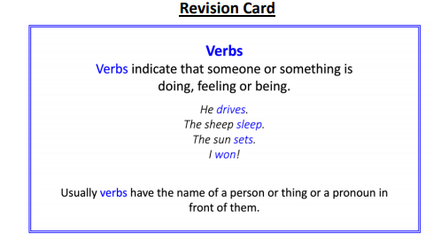

Write a paragraph about what happened next. What trouble did the shepherds get themselves into this time?

- What did the shepherds do?
- Will they get into another mess?
- How will the woman trick them this time?
- Write in the past tense.
- Include direct speech in present tense.

