Butterflies by Kevin Crossley-Holland
The girl sat on the sofa with her homework book on her knee. 'Butterfly Poem' she wrote at the top of the page. She could hear the thump thump-a-thump of the pop music in the flat upstairs.
Then a boy shoved the evening newspaper through the letter-box—and then the telephone rang …
How difficult it was to concentrate.
But after a while the girl caught a few colourful words and set them down on her white page. Then some more. And the more words she caught, the easier they became to catch, the best words in the world.
Next morning, the girl got ready to go to school. She opened her homework book and flicked to the page headed 'Butterfly Poem'.
But where were the words? They had all gone. The girl looked at her book in amazement—she turned it upside down, she checked no page had been torn out, she leafed through it in case the words had somehow escaped to another page . . .
Then it seemed to the girl as if her arms and legs were made of air, and her head was rising through the ceiling. She kissed her mum goodbye and closed the front door .. .
The girl rubbed her eyes. She screwed them up and opened them again. All around her were little scraps of orange and turquoise and jasmine and violet: the whole grey street where she lived was quick and brightly-coloured with hundreds and thousands of butterflies

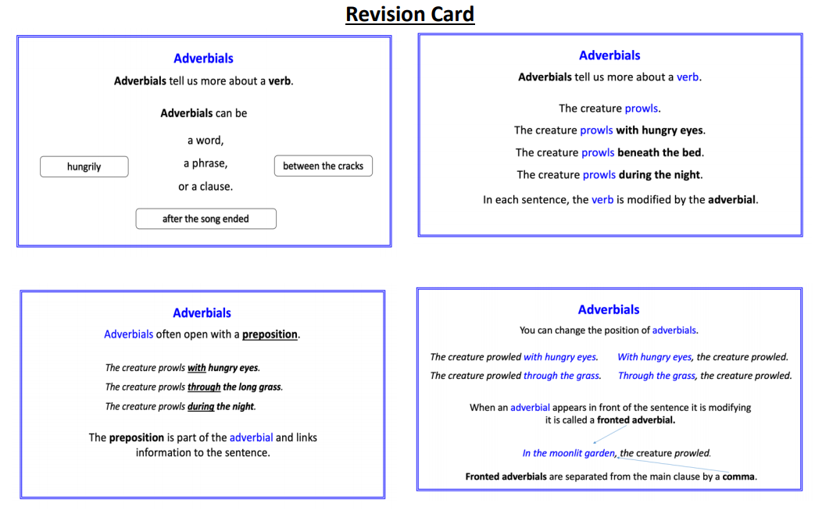
Adverbials 1:
These sentences are adapted from the story. Read them, then choose the best adverbial to add from the list below. Use each once only.

Add the adverbials after the main clause.

1. She peeped
2. The butterflies appeared
3. The people stared
4. Some butterflies followed
5. Later, the girl fell asleep

- after her
- between the curtains
- around the street
- in the air
- in her own bed

Adverbials 2:

Add the adverbials before the main clause.

6. she heard the grandfather clock whirr and strike.
7. they heard the local news.
8. the girl got ready to go to school.
9. she went outside.
10. there was nothing unusual to be seen.

- Next morning
- Before her mother could stop her
- At midnight
- Sadly
- After listening

