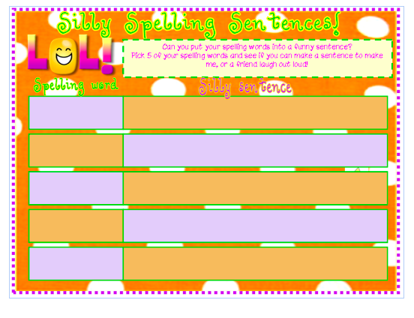

**Spelling words**: *weather, whether, whose, who’s, accept, except, reign, rein, dear, deer*