Picasso inspired Art!

- Take a piece of paper and make diagonal folds, not regular folds to create squares, but random folds.
- Aim to make about 5 different folds and then, using a ruler, go over the fold lines with a black felt tip or pen.
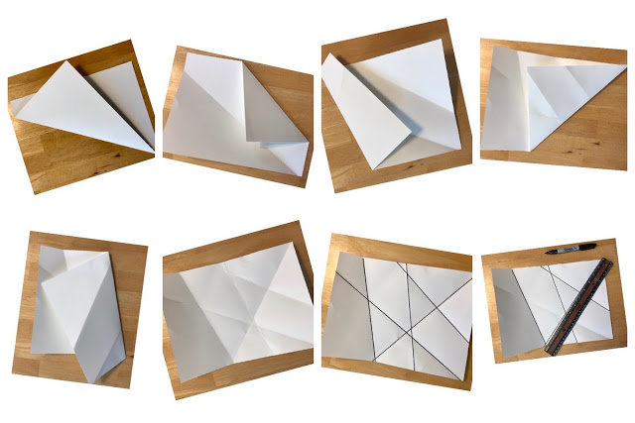

- Looking at the lines on the paper, keep turning it around until you can see the suggestion of a face.
- Using a pencil, begin sketching the parts of the face. Think about the shape and type of lines to use. Include eyes, eyebrows, nose, mouth, chin etc.
- When you are happy with your face, go over it with black felt tip or pen.

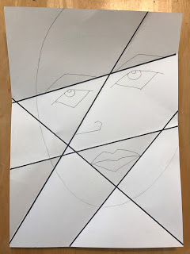
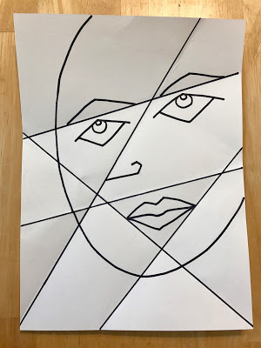
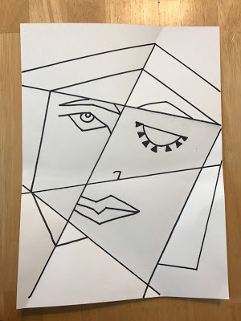

- Using felt pens, paint or colouring pencils, finish the portrait by colouring in each section. Try to use colours that complement next to each other, to try and replicate the style of Picasso.
