ARISTOTLE VS GALILEO: CHALLENGE 2

Aristotle said the heavier things are, the faster they fall.

Galileo said that it is not the mass that makes a difference to how fast things fall.

Who is correct?

• Hold a single sheet of A4 paper horizontally with one hand at either end.
• Drop the paper and time its fall to the ground.
• Repeat this and record the times.

What do you have to remember about how and where you drop the folded sheets of paper from?
• Now fold the paper in half and drop it from the same height and in the same way and record the times.
• Fold it half again and repeat.
• Fold it in half again and repeat.

Paper | Time taken in seconds |  |  |  |  |  | Average time
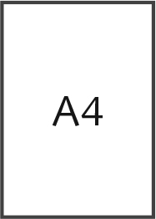

Was Galileo or Aristotle correct about how things fall?
What else is affecting the paper as it falls besides gravity?

