My Pet
Year 2 has decided to make a book about their pets. Here is some information writing from the book.
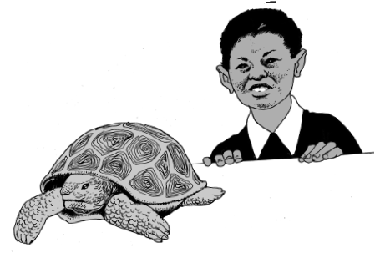
My pet is a tortoise. They can live until they are 100 years old.

In the summer months the tortoise lives in the garden. It has a little wooden shelter to go in. In October we bring him inside because he is ready to go to sleep for the winter. He eats salad, vegetables and dandelion leaves.

Task: Your task is to write an information page on any pet of your choice. Remember to think about where it lives, sleeps, what it eats and any other interesting facts.

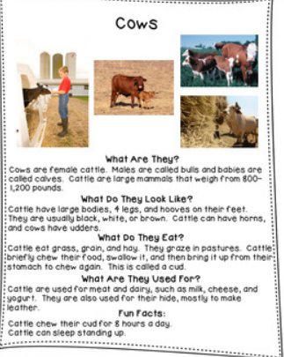
Look at the example and layout your information about your pet clearly using a heading and sub-headings.
In your information text must include…
- a title
- an introduction
- Separate your work into paragraphs
- Start each paragraph with a topic phrase (What do they eat?)
- Write in present tense and third person
- Include technical vocabulary in my writing(mammals, carnivore, domestic)
- Include a range of facts
- Punctuate sentences accurately
- Expand paragraphs with detail

