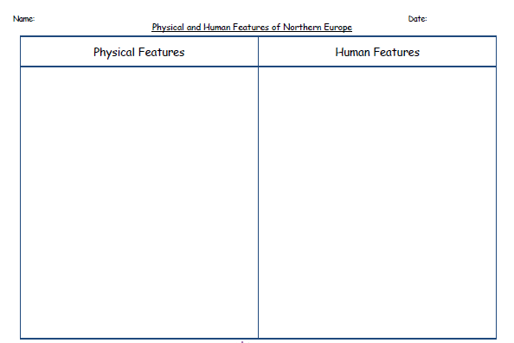

Can you describe some of northern Europe’s physical and human features?

What might you be able to see if you visited Denmark?