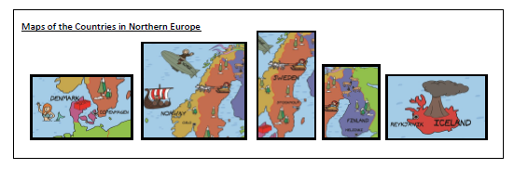

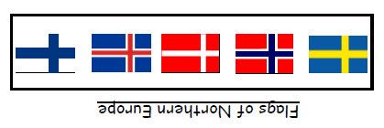

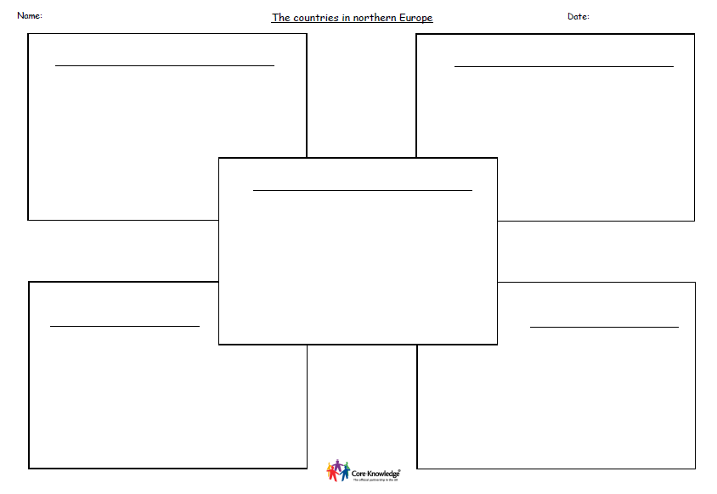

Fill in the information on northern European countries.

Cut out the map of northern European countries and find of the flag of each country. Write some information about each northern Europe country.