Creative Writing

Use the story starter to begin your story.
Success Criteria:
• I can write in paragraphs (your story must contain two or more paragraphs)
• I can include expanded noun phrases
• I can use commas to write longer sentences
• I can include speech
• I can include Fronted Adverbials

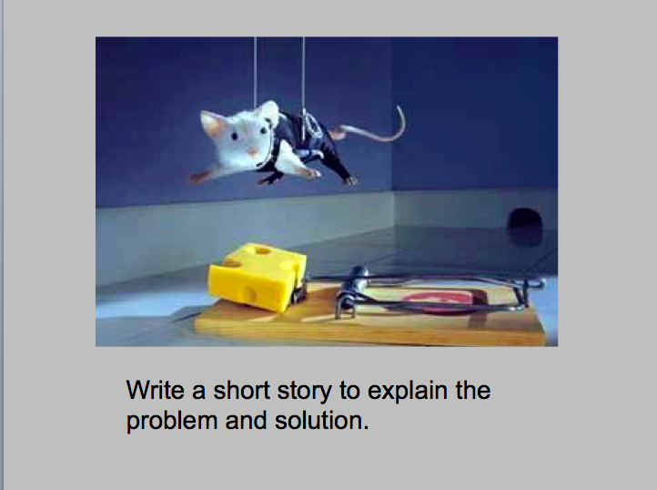

My hair stood on end, a shiver raced down my spine and a lump came to my throat. It was him...
_______________________________________________________________
_______________________________________________________________________________________________________________________________________________________________________________________________________________________________________________________________________________________________________________________________________________________________________________________________________________________________________________________________________________________________________________________________________________________________________________________________________________________________________________________________________________________________________________________________________________________________________________________________________________________________________________________________________________________________________________________________________________________________________________________________________________________________________________________________________________________________________________________________________________________________________________________________________________________________________________________________________________________________________________________________________________________________________________________________________________________________________________________________________________________________________________________________________________________________________________________________________________________________________

