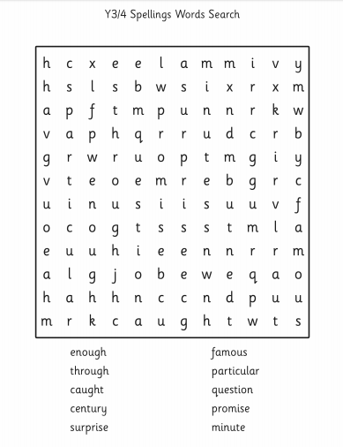

Find the words that have been hidden in the word search. Use each word to write a sentence.