BICEPS

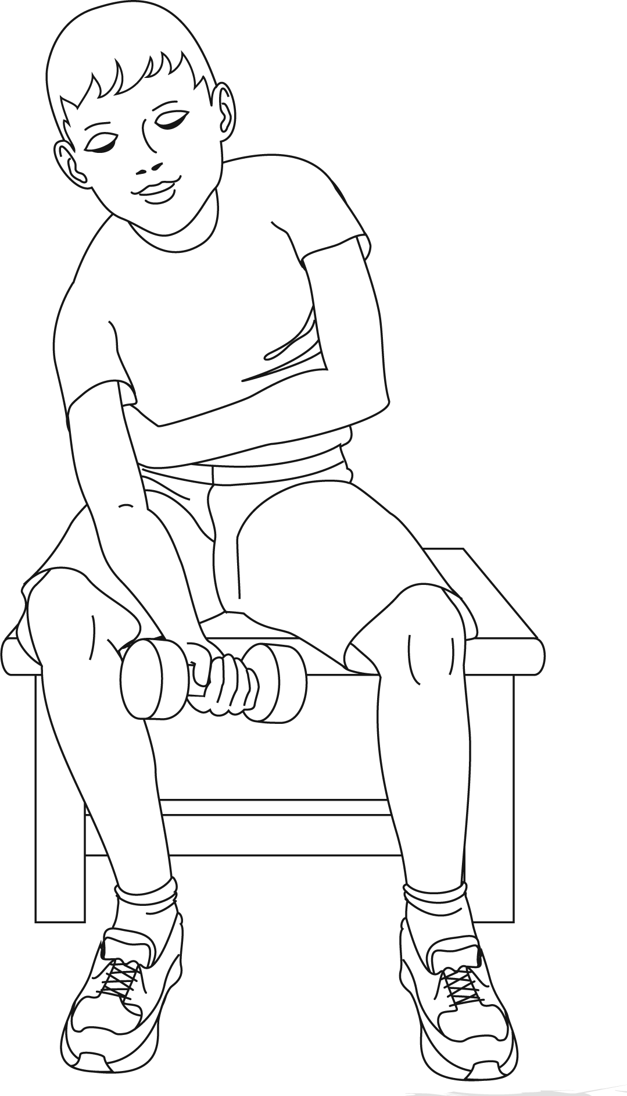

Sit down on a bench.

Hold a small weight in your right hand.

Lean forward slightly and rest your right elbow on your right knee.

Stretch your right arm out fully.

Now slowly bend your arm up, then return to the starting position fully stretching out your arm.

Repeat this several times, swapping arms

TRICEPS



Sit on the floor with your knees bent, your feet on the floor and your hands on the floor behind you, with fingers pointing toward your body.

To begin, lift your bottom off the floor.

Slowly and gently, bend your elbows and lower your body close to the floor and then lift it up again.

Repeat this several times.

ABDOMINALS



Lie flat on your back with your feet pulled in and slightly apart.

Begin to sit up and reach your

hands through between your legs. Then lie back slowly.

Repeat this several times.