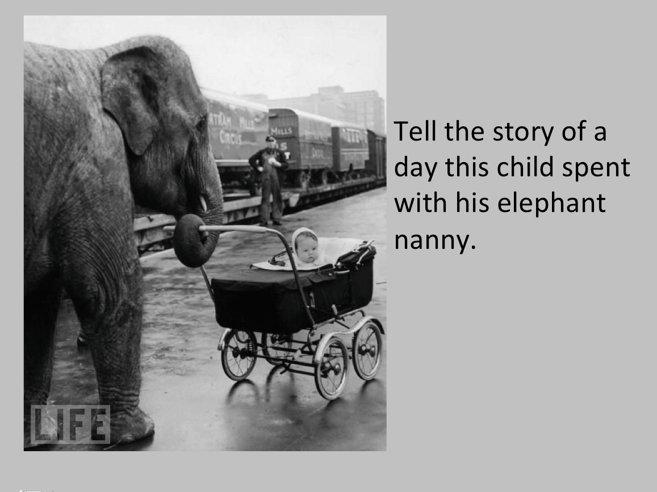

Success Criteria:

. I can write in paragraphs

. I can include Fronted Adverbials

. I can include expanded noun phrases