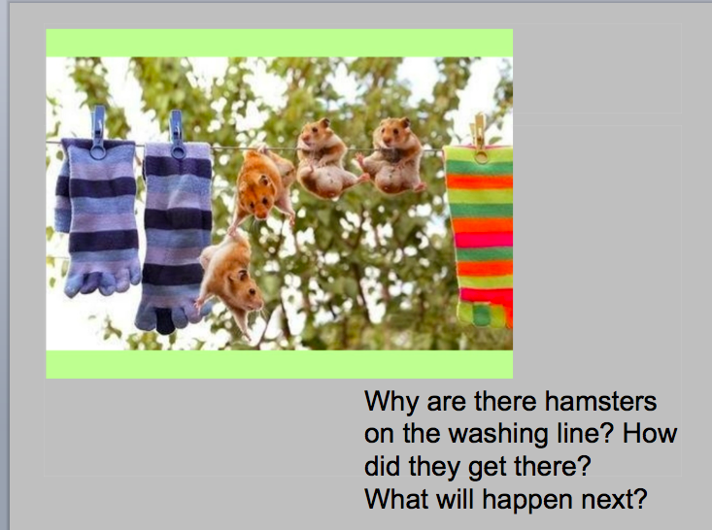

Success Criteria:

* I can write in paragraphs
* I can include Fronted Adverbials
* I can include expanded noun phrases
* I can include commas

.

Tell the story of why there are hamsters on the washing line.





*Remember to use your imagination!*