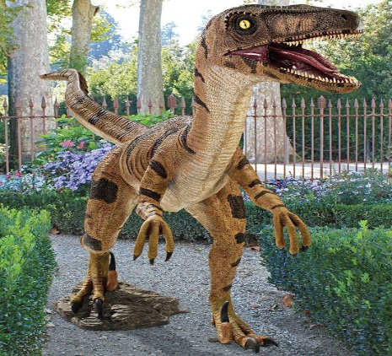
Diary entry - Write a week’s diary on keeping a dinosaur.
Task: Imagine you woke up and saw a dinosaur in your garden or in the play area. Describe what you see and do. Are you going to keep it as your pet? Will you disclose this secret to anyone in your family or your friends? Where are you going to hide it? What are you going to feed it? Do you think you will be able to keep the dinosaur a secret for a long time?
Describe your emotions and feelings at different phases (stages) - For example:
- When you first saw it……
- When you decided to keep it a secret……..
- When your secret was disclosed…….
- When you first started feeding it secretly….
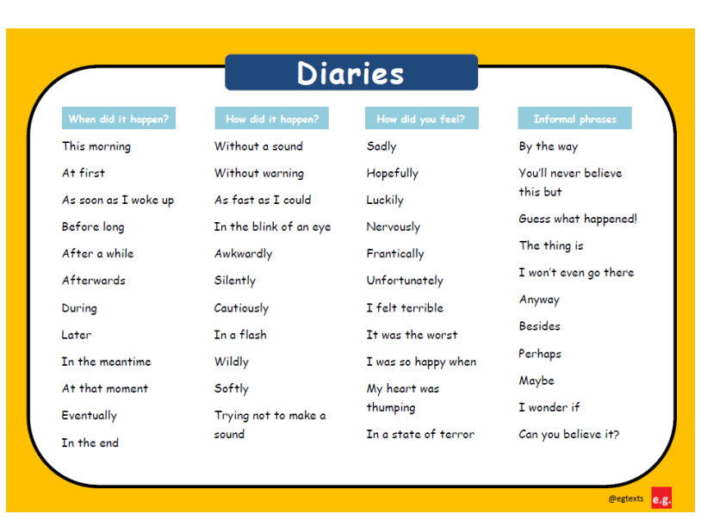
Please use the word map given to write your diary

