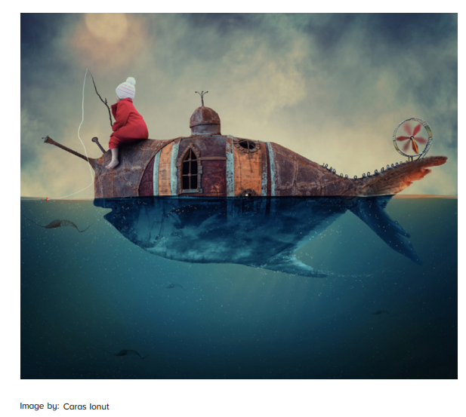
A New World

Question time!
Where do you think the land has gone?
How will people survive in this ‘water-world’?
Is there more land or water on Earth?
Is it better to live in a place with too much water or not enough water?
What do you think the girl had to drink when she was out at sea?

Story starter!
She had already travelled so far, yet still had so much further to go. This was just the beginning of her journey
She began today like every other: sitting with her line in the water, hoping to catch a bite for breakfast.
It had been over three weeks since she had seen another person, three weeks since the land had disappeared…
Continue the story…

