PHONICS WORKSHOP FOR PARENTS / CARERS OF CHILDREN IN YEAR 1

Dear Parents / Carers,

We have organised a Phonics workshop to take place for all parents of children in Year 1 on WEDNESDAY 10th OCTOBER at 9:05am. This is a very important workshop which we expect all parents to attend.
“Phonics is a way of teaching children how to read and write. It helps children hear, identify and use different sounds that distinguish one word from another in the English language. Written language can be compared to a code, so knowing the sounds of individual letters and how those letters sound when they’re combined will help children decode words as they read. Understanding phonics will also help children know which letters to use when they are writing words.”
All children at Parkside learn Phonics from Nursery through to Year 2 and for some of our children in to Key Stage 2. It is the main way we teach them how to read and write and is therefore vital in their development.

For six years children in Year 1 have been tested on their understanding of phonics through a screening check. This will take place again next year for all children in Year 1 in the summer term. You will learn more about this at the workshop. A child’s ability to apply their understanding and application of phonics is one of the key successes in preparing them for a successful career at school.

For those of you unable to attend the PowerPoint slides will be made available on the school website under Latest News and on your child’s Class Page.

We look forward to welcoming many of you on WEDNESDAY 10th OCTOBER

Yours faithfully
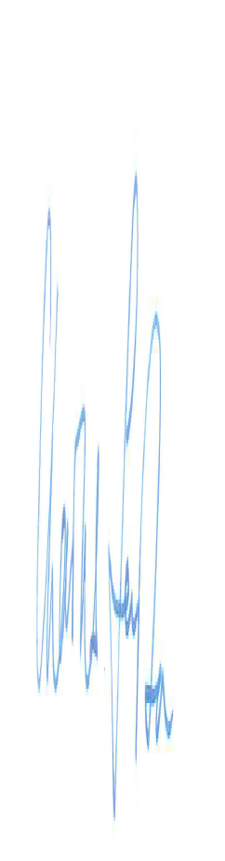

Headteacher

